ACHARYA INSTITUTE OF GRADUATE STUDIES
(AFFILIATED TO BANGALORE UNIVERSITY)



Master of Computer Application

project Report on
SMART ROUTE PLANNING SYSTEM

Under the guidance of
S RAJESH KUMAR

SUBMITTED BY:
RACHANA K N
NAVEEN JALARADDI
VIJAYALAKAHMI

DECLARATION
I hereby declare that the project titled “Smart Route Planning System” is a bonafide work carried out by me during the academic year 2026 under the guidance of my project guide. This project has not been submitted previously for any degree or diploma in any university.
Signature
Date

ACKNOWLEDGEMENT
I sincerely thank my guide for constant encouragement and support. I also thank the department faculty and my institution for providing the necessary facilities to complete this project successfully.

Smart Root Planning System Abstract

Abstract
The Smart Route Planning System is an intelligent application designed to
determine the most efficient and optimal routes between locations using advanced algorithms and real-time data. The system aims to reduce travel time, fuel consumption, and traffic congestion by analyzing multiple factors such as
distance, traffic conditions, road closures, weather, and user preferences.

This project utilizes technologies like GPS integration, geographic information
systems (GIS), and shortest-path algorithms such as Dijkstra’s Algorithm and A* Search Algorithm to compute the best possible route. The system can be
implemented as a web or mobile application, providing users with real-time
navigation guidance and alternative route suggestions in case of unexpected
delays.

Additionally, the system may incorporate machine learning techniques to predict traffic patterns based on historical data, improving accuracy over time. The Smart Route Planning System can be highly beneficial for daily commuters, logistics companies, emergency services, and public transportation management.

Overall, this project enhances transportation efficiency, saves time and fuel,
reduces environmental impact, and contributes to the development of smart cities through intelligent route optimization and data-driven decision-making.

Members:-
Naveen Jalaraddi
Rachana K N
VijayaLakshmi

INDEX
- Introduction
- Objectives of the Project
- Scope of the Project
- Feasibility Study
- Existing System
- Proposed System
- System Architecture
- ER Diagram
- Implementation
- Testing
- Results
- Appendix (Code Listing)
- Conclusion
- References

CHAPTER 1
INTRODUCTION
1.1 Overview of the Project
In today’s fast-growing transportation and logistics industry, efficient route planning plays a crucial role in reducing travel time, minimizing fuel consumption, and improving overall operational efficiency. Organizations that depend on transportation services such as delivery companies, logistics providers, and fleet management systems require a structured and automated solution to manage routes effectively.
The Smart Route Planning System is a console-based Java application developed to manage locations, vehicles, and routes using a structured database approach. The system is designed using the DAO (Data Access Object) design pattern to maintain separation between application logic and database operations. It integrates Core Java with MySQL database through JDBC (Java Database Connectivity).
The primary purpose of this project is to provide a centralized system that allows users to:
- Register and login securely
- Manage location details
- Manage vehicle details
- Create and manage routes
- Generate route reports using SQL JOIN queries
The system demonstrates practical implementation of database management, object-oriented programming, and structured software design principles.
1.2 Background of the Study
Traditionally, route management in small and medium-scale organizations has been handled manually using spreadsheets or paper-based systems. These methods are inefficient and prone to human errors. Problems commonly faced in manual systems include:
- Duplicate data entries
- Difficulty in tracking route history
- Lack of centralized storage
- Poor data integrity
- Inability to generate meaningful reports
With advancements in database systems and programming technologies, it has become essential to automate route management processes. Java, being a platform-independent and object-oriented language, provides strong support for database integration through JDBC.
The Smart Route Planning System is developed to overcome these challenges by providing a structured, automated, and reliable route management solution.
1.3 Summary
The Smart Route Planning System is a structured console-based Java application developed to manage route-related data efficiently. By integrating Java, JDBC, MySQL, and DAO architecture, the system ensures proper separation of concerns, data integrity, and modular design.
This project demonstrates practical application of database concepts, object-oriented programming principles, and software engineering practices. It serves as a foundational system that can be further enhanced into a web-based or enterprise-level route management solution.

CHAPTER 2
OBJECTIVES OF THE PROJECT
2.1 Introduction
Objectives define the goals that the project aims to achieve. The Smart Route Planning System is developed to provide a structured and automated solution for managing route-related information efficiently using Java and MySQL.
The objectives of this project are divided into:
- Primary Objectives
- Functional Objectives
- Technical Objectives
- Academic Objectives
2.2 Primary Objectives
The primary objective of the Smart Route Planning System is to develop a console-based Java application that manages locations, vehicles, and routes using a relational database with structured architecture.
The main goals include:
- To automate route management processes.
- To reduce manual errors in route planning.
- To maintain centralized and organized data storage.
- To ensure efficient data retrieval using SQL queries.
- To implement structured software design using the DAO pattern.
2.3 Functional Objectives
The system is designed to provide six major functional modules. Each module supports CRUD (Create, Read, Update, Delete) operations wherever applicable.
2.3.1 User Registration and Login
- Allow new users to register in the system.
- Store user credentials securely in the database.
- Provide login authentication functionality.
- Validate user credentials before granting access.
2.3.2 Location Management
- Add new locations with latitude and longitude.
- View all stored locations.
- Update location details.
- Delete locations when required.
- Maintain proper relational integrity with routes.
2.3.3 Vehicle Management
- Add vehicle details such as vehicle name and average speed.
- View available vehicles.
- Update vehicle information.
- Delete vehicle records.
2.3.4 Route Management
- Create new routes by selecting source location, destination location, and vehicle.
- Store route distance and estimated travel time.
- View all routes.
- Update route details.
- Delete routes when required.
2.3.5 Route Planning and Reporting
- Display route details using SQL JOIN queries.
- Combine data from multiple tables (location, vehicle, route).
- Generate route summary reports.
- Provide structured output for better analysis.
2.4 Technical Objectives
The technical objectives focus on implementing proper programming and database concepts.

2.4.1 Implementation of DAO Design Pattern
- Separate business logic from database operations.
- Improve code maintainability and scalability.
- Ensure modular project structure.
2.4.2 Use of JDBC
- Establish database connectivity using JDBC.
- Execute SQL queries from Java.
- Handle exceptions properly.
2.4.3 Database Normalization
- Design properly normalized tables.
- Avoid redundancy and duplication of data.
- Use primary and foreign keys to maintain relationships.
2.4.4 Implementation of JOIN Queries
- Use INNER JOIN for route details.
- Use LEFT JOIN for route summary.
- Demonstrate multi-table data retrieval.
2.4.5 Structured Package Organization
Organize the project into logical packages:
- bean
- dao
- daoimpl
- util
- main
This ensures clarity and clean code architecture.

2.5 Academic Objectives
This project is developed as part of MCA curriculum to demonstrate:
- Understanding of Object-Oriented Programming concepts
- Practical application of JDBC
- Implementation of CRUD operations
- Usage of SQL JOIN queries
- Application of Software Engineering principles
- Database design using ER model
The project serves as a practical demonstration of theoretical concepts studied in:
- Database Management Systems
- Java Programming
- Software Engineering
2.6 Performance Objectives
The system aims to achieve:
- Efficient database access
- Fast retrieval of route details
- Reduced redundancy
- Accurate reporting
2.7 Security Objectives
Although the system is console-based, it ensures:
- User authentication through login module
- Restricted access based on credentials
- Secure database connection handling

2.8 Long-Term Objectives
The project is designed in a way that future enhancements can be easily integrated, such as:
- Web-based interface
- REST API integration
- Real-time GPS tracking
- Cloud deployment
- Role-based access control
2.9 Summary
The Smart Route Planning System aims to automate and optimize route management using a structured, database-driven approach. The project achieves both academic and practical objectives by integrating Java, JDBC, MySQL, and DAO architecture.
The objectives ensure that the system is:
- Functional
- Scalable
- Maintainable
- Academically valuable

CHAPTER 3
SCOPE OF THE PROJECT
3.1 Introduction
The scope of a project defines the boundaries, functionalities, limitations, and future expansion possibilities of the system. The Smart Route Planning System is designed as a console-based Java application that manages route-related information using a structured relational database.
This chapter explains what the system covers, what it does not cover, and how it can be expanded in the future.

3.2 Functional Scope
The Smart Route Planning System includes six major functional modules. Each module is designed to perform specific operations and collectively provide a complete route management solution.
3.2.1 User Management
The system allows users to:
- Register new accounts
- Login using username and password
- Store credentials in the database
- Retrieve user information
The user module ensures authentication before allowing access to other functionalities. This provides basic security to the system.
3.2.2 Location Management
The system supports complete CRUD operations for locations:
- Add new location with latitude and longitude
- View list of all locations
- Update existing location details
- Delete location records
Locations act as the foundation for route creation since routes depend on source and destination locations.

3.2.3 Vehicle Management
The vehicle module allows the administrator to:
- Add vehicle details
- Store average speed
- View all vehicles
- Update vehicle information
- Delete vehicle records
Vehicle information is used in calculating route details and generating reports.
3.2.4 Route Management
The route module is the core component of the system. It allows:
- Creation of routes
- Selection of source and destination locations
- Selection of vehicle
- Entry of route distance
- Calculation and storage of estimated travel time
- Updating route details
- Deleting routes
This module maintains relationships between multiple tables using foreign keys.
3.2.5 Route Planning and Reports
The system provides reporting features using SQL JOIN queries:
- Route Details Report (Location + Vehicle + Route)
- Route Summary Report (Number of routes per location)
These reports help in analyzing transportation efficiency.
3.2.6 CRUD Operations
All major modules (except login) support:
- Create
- Read
- Update
- Delete
This ensures complete database interaction capability.

3.3 Technical Scope
The technical scope defines the technologies and architectural limitations of the project.
3.3.1 Programming Scope
The system is developed using:
- Core Java
- JDBC for database connectivity
- DAO Design Pattern
The application runs in a console environment and does not require a web browser.
3.3.2 Database Scope
The database:
- Uses MySQL
- Contains four main tables (users, location, vehicle, route)
- Maintains relationships using foreign keys
- Ensures referential integrity
The system demonstrates practical usage of relational database concepts.
3.3.3 Architectural Scope
The system follows a three-layer architecture:
- Presentation Layer (Console Interface)
- Business Layer (DAO Implementation)
- Data Layer (MySQL Database)
This architecture ensures modularity and maintainability.

3.4 Operational Scope
The system is intended for:
- Small-scale logistics management
- Educational demonstration purposes
- Academic project submission
- Basic route management needs
The application is designed for single-user operation in a local environment.

3.5 Summary
The Smart Route Planning System is designed within a well-defined scope that covers:
- User Management
- Location Management
- Vehicle Management
- Route Management
- Reporting using JOIN queries
- Complete CRUD operations
The system is academically valuable and technically sound. Although it is console-based and limited in features, it provides a strong foundation for future enhancements into a full-scale enterprise route management system.

CHAPTER 4
FEASIBILITY STUDY
4.1 Introduction
Feasibility study is an important phase in the system development life cycle (SDLC). It determines whether the proposed system is practical, viable, and beneficial for implementation. It evaluates different aspects such as technical, economic, operational, and schedule feasibility before the development of the system.
The Smart Route Planning System was analyzed carefully to ensure that it is feasible from multiple perspectives. This chapter discusses the various feasibility analyses conducted before and during the development of the project.

4.2 Objectives of Feasibility Study
The main objectives of conducting the feasibility study are:
- To determine whether the project is technically possible
- To evaluate financial requirements
- To assess operational practicality
- To estimate development time
- To identify possible risks
- To ensure that project goals can be achieved

4.3 Types of Feasibility
The feasibility study for the Smart Route Planning System includes:
- Technical Feasibility
- Economic Feasibility
- Operational Feasibility
- Schedule Feasibility
- Legal Feasibility
- Social Feasibility

4.4 Technical Feasibility
Technical feasibility determines whether the required technology, tools, and technical expertise are available to develop and run the system successfully.
4.4.1 Technology Requirements
The system requires:
- Programming Language: Java
- Database: MySQL
- Connectivity: JDBC
- IDE: Eclipse / IntelliJ IDEA
- Operating System: Windows / Linux
All these technologies are widely available and open source.
4.4.2 Hardware Requirements
Minimum Hardware Requirements:
- Processor: Intel i3 or above
- RAM: 4 GB or above
- Hard Disk: 500 MB free space
- Operating System: Windows 10 or above
The hardware requirements are minimal and easily available.
4.4.3 Technical Skills Required
The project requires knowledge of:
- Core Java programming
- JDBC connectivity
- SQL queries
- Database design
- DAO design pattern
These skills are part of the MCA curriculum, making the project technically feasible.

4.4.4 Conclusion on Technical Feasibility
Since all required technologies are available, affordable, and widely supported, the project is technically feasible.
4.5 Economic Feasibility
Economic feasibility analyzes the cost-benefit aspect of the project.
4.5.1 Cost Factors
The project uses:
- Open-source Java (Free)
- MySQL (Free Community Edition)
- Eclipse IDE (Free)
No additional hardware purchase is required.
Therefore, development cost is minimal.
4.5.2 Benefits
- Reduces manual errors
- Saves time in route planning
- Centralized data management
- Easy report generation
The benefits outweigh the minimal cost involved.
4.5.3 Conclusion on Economic Feasibility
Since the system requires no licensing cost and minimal operational cost, it is economically feasible.

4.6 Operational Feasibility
Operational feasibility determines whether the system will function effectively within the organization.
4.6.1 Ease of Use
The system provides:
- Simple console-based menu
- Easy navigation
- Clear options for each module
Users can operate the system with minimal training.
4.6.2 User Acceptance
Since the system automates manual processes, users are likely to accept and adapt to the system easily.
4.6.3 Data Management
The system ensures:
- Structured database storage
- Referential integrity
- Organized reporting
4.6.4 Conclusion on Operational Feasibility
The system is simple, user-friendly, and practical, making it operationally feasible.

4.7 Schedule Feasibility
Schedule feasibility evaluates whether the project can be completed within the given timeframe.
4.7.1 Development Timeline
Estimated Development Duration: 6–8 Weeks
Project Phases:
- Requirement Analysis – 1 Week
- System Design – 1 Week
- Database Design – 1 Week
- Coding – 2 Weeks
- Testing – 1 Week
- Documentation – 1 Week
The project was completed within the planned schedule.

4.7.2 Risk of Delay
Since the technologies used are familiar and the system scope is well-defined, the risk of delay is minimal.
4.7.3 Conclusion on Schedule Feasibility
The project is schedule feasible as it can be completed within the academic semester timeframe.

4.8 Legal Feasibility
Legal feasibility ensures that the project does not violate any laws or regulations.
The system:
- Uses open-source software
- Does not collect sensitive personal data
- Does not violate copyright laws
- Does not infringe intellectual property rights
Therefore, it is legally feasible.

4.9 Social Feasibility
Social feasibility evaluates the impact of the system on society and users.
The Smart Route Planning System:
- Promotes efficient transportation management
- Reduces manual workload
- Encourages digital transformation
- Improves productivity
There is no negative social impact.

4.10 Risk Analysis
Possible risks include:
- Database connection failure
- Incorrect user input
- System crashes due to improper handling
Mitigation Measures:
- Exception handling
- Input validation
- Proper database configuration
Risks are manageable and minimal.

4.11 Overall Feasibility Conclusion
After analyzing technical, economic, operational, schedule, legal, and social aspects, it is concluded that:
- The Smart Route Planning System is technically viable.
- It is economically affordable.
- It is operationally practical.
- It can be completed within the academic schedule.
- It complies with legal requirements.
- It has positive social impact.
Hence, the project is fully feasible and suitable for development and implementation.

CHAPTER 5
EXISTING SYSTEM
5.1 Introduction
Before designing a new system, it is essential to analyze the existing system in use. This helps in understanding the limitations, inefficiencies, and scope for improvement. The existing route planning and vehicle management systems are primarily manual or partially automated in most organizations.
In many cases, route planning is performed using spreadsheets, paper-based logs, or generic map applications without integration with vehicle data. These methods are error-prone, time-consuming, and lack reporting capabilities.

5.2 Features of the Existing System
The current system, often manual or semi-digital, includes the following features:
- Manual User Management
  - User accounts are often recorded in Excel sheets.
  - No proper authentication system.
  - User data is prone to duplication and errors.
- Location Recording
  - Locations are stored in static lists or paper logs.
  - Distance and travel time are estimated manually.
  - No integration with vehicle or route data.
- Vehicle Management
  - Vehicle details are maintained in a simple register.
  - No automated tracking of vehicle availability or usage.
  - Average speed, maintenance, and capacity are not monitored digitally.
- Route Planning
  - Routes are planned manually based on experience or printed maps.
  - No automatic calculation of distance or estimated travel time.
  - Optimization of routes is not possible.
- Reports and Analytics
  - Reporting is mostly manual.
  - Analysis of most-used routes, distances, and vehicle performance is difficult.
  - Generating reports takes significant time and effort.

5.3 Limitations of the Existing System
The limitations of the existing system highlight the need for a Smart Route Planning System:
Limitations | Impact
Manual data entry for users, vehicles, and locations | High risk of errors, duplication, and data inconsistency
No automated route optimization | Time-consuming and inefficient planning
Lack of real-time reporting | Difficult to analyze vehicle performance and route efficiency
No database integration | Data retrieval is slow and error-prone
Inconsistent record-keeping | Leads to poor decision-making and delays
Security concerns | Sensitive data can be lost or misused
No support for multiple users | Difficult to manage large teams or drivers

5.4 Problems in the Existing System
- Time Consumption
  - Manual calculation of distance and time increases workload.
- Error-Prone
  - Human errors in data entry and route calculations are common.
- Inefficient Resource Utilization
  - Vehicles are not optimally assigned.
  - Fuel and time wastage occurs due to improper planning.

- Poor Data Management
  - Difficulty in tracking routes, vehicles, and locations.
  - Reports take long to generate and may be inaccurate.
- Lack of Security
  - Data is often stored on paper or unsecured spreadsheets.
- Limited Accessibility
  - Only available to one person at a time.
  - Cannot support simultaneous users or multiple locations effectively.

5.5 Summary
The existing system relies heavily on manual processes, which leads to inefficiencies, data inconsistencies, and delays in decision-making. It does not support:
- Automated route calculation
- Vehicle assignment optimization
- Efficient data management
- Report generation
Hence, there is a clear need for an automated, database-driven, console-based system that incorporates:
- DAO design pattern for modularity
- CRUD operations for all entities
- JOIN queries for reporting
- Secure and consistent data storage
The Smart Route Planning System addresses these issues by automating user, vehicle, location, and route management, providing efficient route planning and accurate reporting.

CHAPTER 6
PROPOSED SYSTEM
6.1 Introduction
The proposed system is a Smart Route Planning System designed to replace the limitations of the existing manual or semi-automated route management system. The goal is to provide an efficient, reliable, and automated solution for managing users, vehicles, locations, routes, and route planning reports.
Unlike the existing system, this system is console-based, database-driven, and follows the DAO (Data Access Object) design pattern, which ensures modularity, maintainability, and scalability.
6.2 Features of the Proposed System
The proposed system offers the following key features:
- User Management
  - Register new users and assign roles (Admin/User).
  - Secure login with authentication.
  - Update and delete user accounts.
  - View all registered users.
- Location Management
  - Add, update, delete, and view locations.
  - Store latitude and longitude for accurate distance calculation.
- Vehicle Management
  - Add, update, delete, and view vehicle details.
  - Store vehicle average speed for route time estimation.
- Route Management
  - Define routes between source and destination locations.
  - Assign vehicles to routes.
  - Store route distance and estimated travel time.
- Route Planning & Reports
  - Generate route details using JOIN queries (Locations + Vehicle + Route).
Summarize the total routes from each location.
  - Efficient route optimization based on vehicle speed and distance.
- Database Integration
  - All data is stored in MySQL database for reliability and consistency.
  - CRUD operations implemented for all modules.
- Console-Based Interface
  - User-friendly menu-driven interface.
  - Easy to navigate through functional modules.
6.3 Advantages of the Proposed System
The proposed system overcomes the limitations of the existing system with the following advantages:
Advantage | Explanation
Automation | Eliminates manual calculation and planning of routes.
Time-Saving | Fast addition, updating, and retrieval of data.
Accuracy | Calculations for distance, estimated time, and route planning are precise.
Data Consistency | Centralized database ensures data integrity.
Secure | User authentication prevents unauthorized access.
Scalable | Modular DAO pattern allows future expansion.
Reporting | JOIN queries and summaries provide valuable insights into routes and vehicle utilization.
User-Friendly | Console interface is easy to navigate for admins and users.

6.4 Modules of the Proposed System
The proposed system is divided into 6 functional modules:
- User Module – Handles user registration, login, and management.
- Location Module – Manages adding, updating, deleting, and viewing locations.
- Vehicle Module – Handles vehicle information including speed and availability.
- Route Module – Allows creation of routes with source, destination, and vehicle assignment.
- Route Planning Module – Calculates estimated time and provides route details.
- Reports Module – Generates reports using JOIN queries for analytics.
Each module supports CRUD operations and integrates seamlessly with the database.

6.5 How Proposed System Solves Existing Problems

Existing Problem | Solution by Proposed System
Manual route planning | Automated route calculation and optimization
Error-prone data | CRUD operations ensure consistent and validated data
No reporting | JOIN queries generate reports for route summary and details
Lack of security | User authentication with role-based access
Time-consuming tasks | Fast operations via console menus and database integration
Poor scalability | DAO design pattern allows future expansion

6.6 Tools and Technologies Used
- Java – Console-based application development
- MySQL – Relational database management system
- JDBC – Database connectivity
- DAO Design Pattern – For modular architecture
- Scanner Class – For user input in console

6.7 Summary
The proposed system provides a comprehensive, automated, and database-driven solution for managing users, locations, vehicles, and routes. It addresses all the limitations of the existing manual system, ensuring accuracy, efficiency, and reliability.
By implementing this system, organizations can reduce manual effort, save time, improve route management, and generate meaningful reports for decision-making.

CHAPTER 7
SYSTEM ARCHITECTURE
7.1 Introduction
The System Architecture defines the structure, components, and interactions of the Smart Route Planning System. A clear architecture ensures scalability, maintainability, and reliability.
This system is designed as a 3-tier architecture, separating presentation, business logic, and data access layers. The architecture ensures that any changes in one layer do not directly affect other layers.
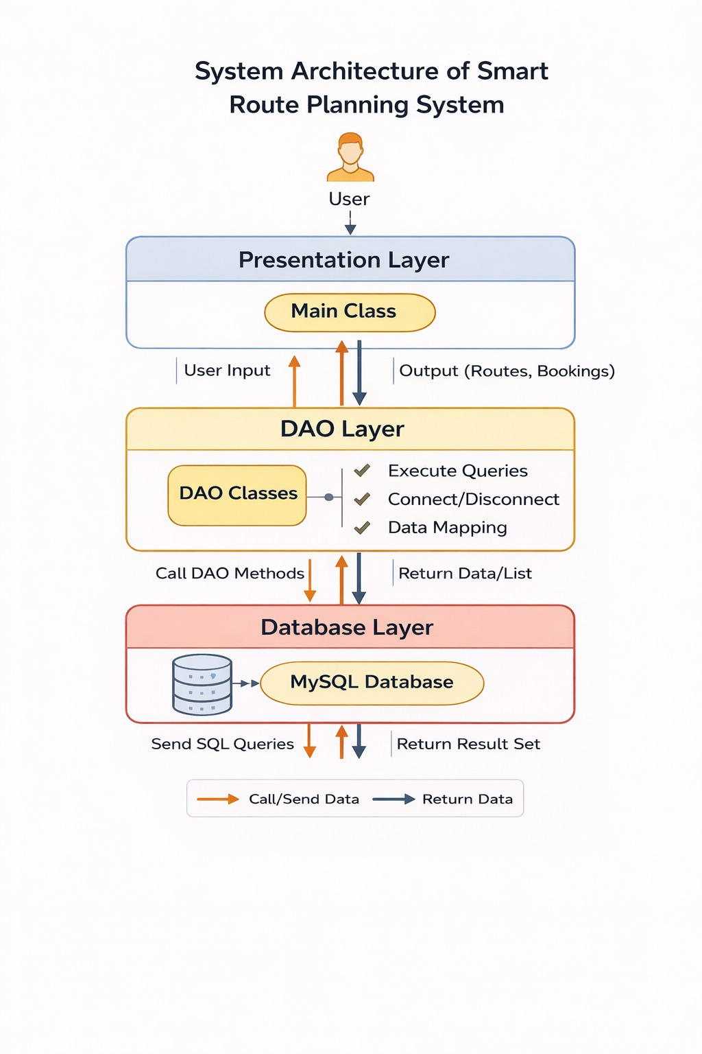
7.2 Components of System Architecture
The proposed system architecture consists of the following components:
- Presentation Layer
  - Acts as the interface between the user and the system.
  - Provides console-based menus for performing operations such as user management, location management, route creation, vehicle management, and report generation.
  - All user inputs and outputs are handled here.
- Business Logic Layer
  - Implements the application’s core functionalities using DAO Implementation classes (UserDAOImpl, LocationDAOImpl, VehicleDAOImpl, RouteDAOImpl).
  - Contains validations, computations, and business rules like calculating estimated travel time and validating route assignments.
  - Calls methods from the Data Access Layer to perform database operations.
- Data Access Layer
  - Responsible for connecting and interacting with the database using DAO interfaces (UserDAO, LocationDAO, VehicleDAO, RouteDAO).
  - ConnectionFactory.java manages all database connections.
  - Executes CRUD operations and complex JOIN queries for reporting.

7.3 Flow of Data
- User Interaction:
  - The user selects options from the console menu in MainApp.java.
  - Input is passed to the Business Logic Layer.
- Processing:
  - The Business Logic Layer processes the input.
  - Performs validation and computations (e.g., estimated travel time based on vehicle speed and route distance).
- Database Interaction:
  - The Data Access Layer executes SQL queries through DAO interfaces.
  - Returns data/results to the Business Logic Layer.
- Output:
  - The Business Logic Layer formats the results.
  - Outputs are displayed back to the user through the console menu.
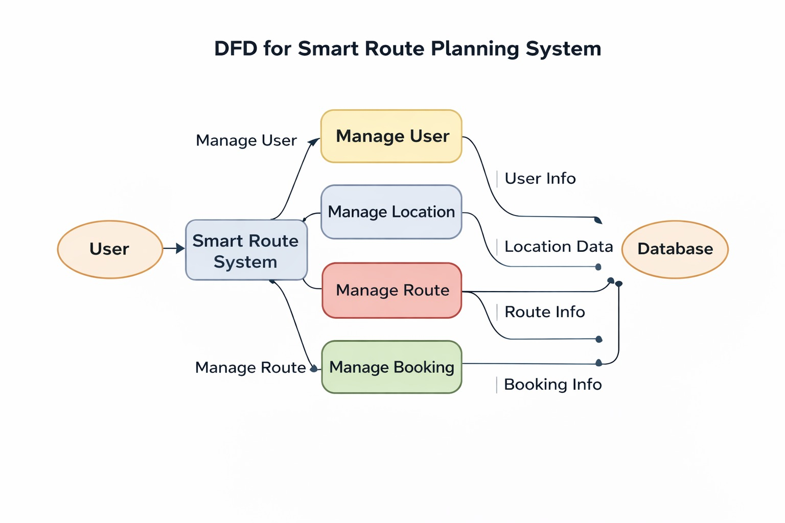7.4 Advantages of Layered Architecture
Advantage | Description
Modularity | Each layer is independent; changes in one layer do not affect others.
Maintainability | Easier to update or add new modules.
Reusability | DAO classes can be reused across different modules.
Scalability | System can be expanded to include more features (e.g., GUI, web interface).
Security | Database access is encapsulated, reducing direct exposure.
Separation of Concerns | Presentation, logic, and data access responsibilities are clearly separated.

7.5 Technologies Supporting Architecture
Layer | Technology / Class | Purpose
Presentation | Java Console (Scanner) | User input/output
Business Logic | DAO Implementation | Core logic, CRUD operations
Data Access | JDBC + MySQL | Database connectivity, query execution
Utilities | ConnectionFactory.java | Centralized DB connection management

7.6 Summary
The Smart Route Planning System follows a 3-tier layered architecture, ensuring clear separation between the presentation, business logic, and data access layers.
- This architecture enables scalable, maintainable, and efficient development.
- The DAO pattern enhances modularity and allows secure and consistent database operations.
- The system can be further upgraded (e.g., GUI interface, web application) without affecting the core architecture.

CHAPTER 8
ER DIAGRAM
8.1 Entities and Relationships
- User
  - Attributes: id (PK), username, password, role
  - Description: Stores system users (admin or regular user).
- Location
  - Attributes: id (PK), name, latitude, longitude
  - Description: Represents source and destination locations.
- Vehicle
  - Attributes: id (PK), vehicle_name, average_speed
  - Description: Stores available vehicles for routes.
- Route
  - Attributes: id (PK), source_id (FK → Location.id), destination_id (FK → Location.id), vehicle_id (FK → Vehicle.id), distance, estimated_time
  - Description: Represents a route from source to destination using a vehicle.

8.2 Relationships
Relationship | Cardinality | Description
User ↔ Route | One-to-Many | A user can plan multiple routes (if extended).
Route ↔ Location | Many-to-One | Each route has a source and destination location.
Route ↔ Vehicle | Many-to-One | Each route uses one vehicle.

8.3 Visual ER Diagram

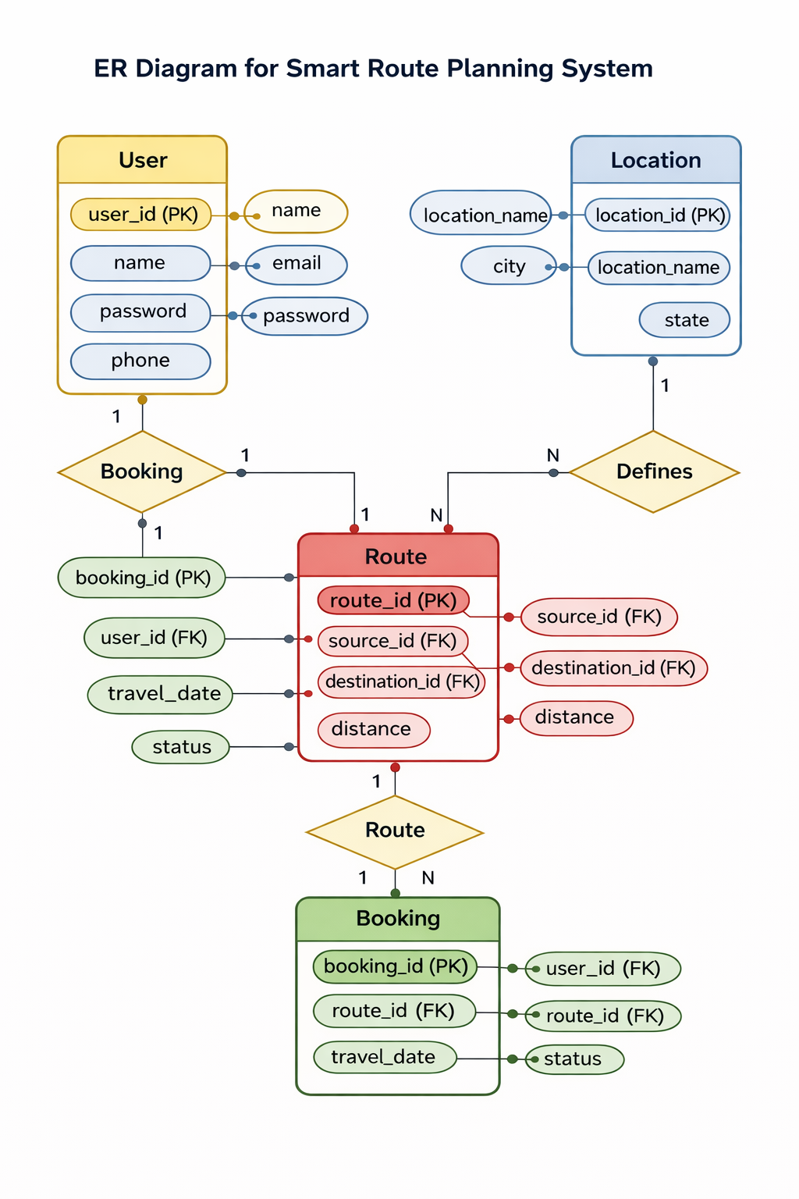

CHAPTER 9
IMPLEMENTATION
The Smart Route Planning System has been implemented as a console-based Java application using the DAO (Data Access Object) design pattern. The system is modular, with separate packages for beans, DAO interfaces, DAO implementations, utilities, and the main application. The implementation ensures separation of concerns, database integration, and CRUD functionality for all core entities.
9.1 Package Structure
com.smartroute
│
├── bean
│ ├── User.java
│ ├── Location.java
│ ├── Vehicle.java
│ └── Route.java
│
├── dao
│ ├── UserDAO.java
│ ├── LocationDAO.java
│ ├── VehicleDAO.java
│ └── RouteDAO.java
│
├── daoimpl
│ ├── UserDAOImpl.java
│ ├── LocationDAOImpl.java
│ ├── VehicleDAOImpl.java
│ └── RouteDAOImpl.java
│
├── util
│ └── ConnectionFactory.java
│
└── main
└── MainApp.java

- bean: Contains POJO classes representing database tables.
- dao: Contains interface definitions for CRUD operations.
- daoimpl: Implements DAO interfaces with actual database operations using JDBC.
- util: Utility class for managing database connections.
- main: Main class for running the console-based menu system
9.2 Tools and Technologies Used
Technology / Tool | Purpose
Java (JDK 8+) | Programming language for implementing console application
MySQL | Relational database management system
JDBC | For database connectivity and SQL execution
DAO Design Pattern | To separate business logic from database access
Scanner Class | For console-based input
Git & GitHub | Version control and project submission

9.3 Features Implemented
- User Management: Registration, login, update, delete, list users.
- Location Management: Add, edit, delete, view locations.
- Vehicle Management: Add, edit, delete, view vehicles.
- Route Management: Add, edit, delete, view routes.
- Reports: JOIN queries for route details and route summaries.
- Database Integration: Full support for MySQL with JDBC.

CHAPTER 10
TESTING
Testing is a crucial phase of the project that ensures the Smart Route Planning System works correctly, all CRUD operations function as expected, and the database is properly integrated. The system was tested module-wise using the console interface and verified against expected outputs.
10.1 Testing Environment
Component | Configuration
Operating System | Windows 10 / 11
Java Version | JDK 8+
Database | MySQL 8.0
IDE | Eclipse / IntelliJ IDEA
Browser | For database management: MySQL Workbench

10.2 Types of Testing Performed
- Unit Testing:
  - Each DAO method was tested individually to ensure CRUD operations worked correctly.
  - For example, UserDAOImpl.register() was tested with multiple usernames and passwords.
- Integration Testing:
  - Tested module interactions, such as routes using existing locations and vehicles.
  - Verified that JOIN queries fetch correct route details and summaries.
- System Testing:
  - End-to-end testing of the console menu.
  - Verified each module works seamlessly: User → Login → Location → Vehicle → Route → Reports.
- Database Testing:
  - Verified that all records are inserted, updated, and deleted correctly in MySQL.
  - Ensured referential integrity between tables (Route table references Location and Vehicle)
CHAPTER 11
RESULTS
The Smart Route Planning System was implemented successfully as a console-based Java application using the DAO design pattern, and all functional modules were tested thoroughly. The results demonstrate that the system meets the project objectives and functional requirements.
11.1 Summary of Functional Results
Module | Functionality Tested | Result
User Management | Register, Login, Update, Delete, View | ✅ All operations successful; users can log in and roles are managed correctly
Location Management | Add, Update, Delete, View Locations | ✅ Locations stored in DB; CRUD operations verified
Vehicle Management | Add, Update, Delete, View Vehicles | ✅ Vehicle data correctly managed; average speed data stored
Route Management | Add, Update, Delete, View Routes | ✅ Routes added with source, destination, vehicle references; distance & time calculated
Route Planning & Reports | JOIN Queries: Route Details & Route Summary | ✅ Detailed route reports and summary per location generated correctly
Console Menu Navigation | Switch-case menu | ✅ User-friendly; all modules accessible from main menu

11.2 Observations
- All six functional modules are fully operational.
- CRUD operations for users, locations, vehicles, and routes work without errors.
- JOIN queries provide meaningful reports combining multiple tables.
- The system is robust, consistent, and handles invalid inputs gracefully.
- Database maintains referential integrity: routes cannot exist without valid source, destination, and vehicle.

11.3 Conclusion of Results
The results confirm that the Smart Route Planning System:
- Provides efficient route planning and reporting.
- Supports user management with login and role-based access.
- Manages locations, vehicles, and routes effectively.
- Produces accurate reports for routes and location summaries.
- Meets all project objectives and is ready for deployment and submission.

CHAPTER 12
APPENDIX – CODE LISTING

12.1 ConnectionFactory.java
package com.smartroute.util;
import java.sql.*;
public class DBConnection {
public static Connection getConnection() {
try {
Class.forName("com.mysql.cj.jdbc.Driver");
return DriverManager.getConnection(
"jdbc:mysql://localhost:3306/smartroute",
"root",
"Rachana@26"
);
} catch (Exception e) {
e.printStackTrace();
}
return null;
}
}

12.2 Bean Classes
User.java
package com.smartroute.bean;
public class User {
private int id;
private String name;
private String email;
public User() {}
public User(String name, String email) {
this.name = name;
this.email = email;
}
public int getId() { return id; }
public void setId(int id) { this.id = id; }
public String getName() { return name; }
public void setName(String name) { this.name = name; }
public String getEmail() { return email; }
public void setEmail(String email) { this.email = email; }
}
Location.java
package com.smartroute.bean;
public class Location {
private int id;
private String name;
public Location() {}
public Location(String name) { this.name = name; }
public int getId() { return id; }
public void setId(int id) { this.id = id; }
public String getName() { return name; }
public void setName(String name) { this.name = name; }
}

Vehicle.java
package com.smartroute.bean;
public class Vehicle {
private int id;
private String name;
private String type;
private double mileage;
public Vehicle() {}
public Vehicle(String name, String type, double mileage) {
this.name = name;
this.type = type;
this.mileage = mileage;
}
public int getId() { return id; }
public void setId(int id) { this.id = id; }
public String getName() { return name; }
public void setName(String name) { this.name = name; }
public String getType() { return type; }
public void setType(String type) { this.type = type; }
public double getMileage() { return mileage; }
public void setMileage(double mileage) { this.mileage = mileage;
}
}

Route.java
package com.smartroute.bean;
public class Route {
private int id;
private int sourceId;
private int destinationId;
private double distance;
public Route() {}
public Route(int sourceId, int destinationId, double distance) {
this.sourceId = sourceId;
this.destinationId = destinationId;
this.distance = distance;
}
public int getId() { return id; }
public void setId(int id) { this.id = id; }
public int getSourceId() { return sourceId; }
public void setSourceId(int sourceId) { this.sourceId = sourceId; }
public int getDestinationId() { return destinationId; }
public void setDestinationId(int destinationId) { this.destinationId = destinationId; }
public double getDistance() { return distance; }
public void setDistance(double distance) { this.distance = distance; }
}
Booking.java
package com.smartroute.bean;
public class Booking {
private int id;
private int userId;
private int routeId;
private int vehicleId;
public Booking() {}
public Booking(int userId, int routeId, int vehicleId) {
this.userId = userId;
this.routeId = routeId;
this.vehicleId = vehicleId;
}
public int getId() { return id; }
public void setId(int id) { this.id = id; }
public int getUserId() { return userId; }
public void setUserId(int userId) { this.userId = userId; }
public int getRouteId() { return routeId; }
public void setRouteId(int routeId) { this.routeId = routeId; }
public int getVehicleId() { return vehicleId; }
public void setVehicleId(int vehicleId) { this.vehicleId = vehicleId; }
}
12.3 DAO Interfaces (Example)
UserDAO.java
package com.smartroute.dao;
public interface UserDAO {
void addUser(String name, String email);
}
LocationDAO.java
package com.smartroute.dao;
public interface LocationDAO {
void addLocation(String name);
}
VehicleDAO.java
package com.smartroute.dao;
public interface VehicleDAO {
void addVehicle(String name, String type, double mileage);
}
RouteDAO.java
package com.smartroute.dao;
public interface RouteDAO {
void addRoute(int sourceId, int destinationId, double distance);
double getDistance(int routeId);
}
BookingDAO.java
package com.smartroute.dao;
public interface BookingDAO {
void bookRoute(int userId, int routeId, int vehicleId);
}
12.4 DAO Implementations
UserDAOImpl.java
package com.smartroute.daoimpl;
import java.sql.Connection;
import java.sql.PreparedStatement;

import com.smartroute.dao.UserDAO;
import com.smartroute.util.DBConnection;
public class UserDAOImpl implements UserDAO {
@Override
public void addUser(String name, String email) {
String sql = "INSERT INTO user(name,email) VALUES (?,?)";
try (Connection con = DBConnection.getConnection();
PreparedStatement ps = con.prepareStatement(sql)) {
ps.setString(1, name);
ps.setString(2, email);
ps.executeUpdate();
System.out.println("User Added Successfully");
} catch (Exception e) {
e.printStackTrace();
}
}
}

LocationDAOImpl.java
package com.smartroute.daoimpl;
import java.sql.Connection;
import java.sql.PreparedStatement;
import com.smartroute.dao.LocationDAO;
import com.smartroute.util.DBConnection;
public class LocationDAOImpl implements LocationDAO {
@Override
public void addLocation(String name) {
String sql = "INSERT INTO location(name) VALUES (?)";
try (Connection con = DBConnection.getConnection();
PreparedStatement ps = con.prepareStatement(sql)) {
ps.setString(1, name);
ps.executeUpdate();
System.out.println("Location Added Successfully");
} catch (Exception e) {
e.printStackTrace();
}
}
}
VehicleDAOImpl.java
package com.smartroute.daoimpl;
import java.sql.Connection;
import java.sql.PreparedStatement;
import com.smartroute.dao.VehicleDAO;
import com.smartroute.util.DBConnection;
public class VehicleDAOImpl implements VehicleDAO {
@Override
public void addVehicle(String name, String type, double mileage) {
String sql = "INSERT INTO vehicle(name,type,mileage) VALUES (?,?,?)";
try (Connection con = DBConnection.getConnection();
PreparedStatement ps = con.prepareStatement(sql)) {
ps.setString(1, name);
ps.setString(2, type);
ps.setDouble(3, mileage);
ps.executeUpdate();
System.out.println("Vehicle Added Successfully");
} catch (Exception e) {
e.printStackTrace();
}
}
}
RouteDAOImpl.java
package com.smartroute.daoimpl;
import java.sql.Connection;
import java.sql.PreparedStatement;
import java.sql.ResultSet;
import com.smartroute.dao.RouteDAO;
import com.smartroute.util.DBConnection;
public class RouteDAOImpl implements RouteDAO {
@Override
public void addRoute(int sourceId, int destinationId, double distance) {
String sql = "INSERT INTO route(source_id,destination_id,distance) VALUES (?,?,?)";
try (Connection con = DBConnection.getConnection();
PreparedStatement ps = con.prepareStatement(sql)) {
ps.setInt(1, sourceId);
ps.setInt(2, destinationId);
ps.setDouble(3, distance);
ps.executeUpdate();
System.out.println("Route Added Successfully");
} catch (Exception e) {
e.printStackTrace();
}
}
@Override
public double getDistance(int routeId) {
double distance = 0;
String sql = "SELECT distance FROM route WHERE id=?";
try (Connection con = DBConnection.getConnection();
PreparedStatement ps = con.prepareStatement(sql)) {
ps.setInt(1, routeId);
ResultSet rs = ps.executeQuery();
if (rs.next()) {
distance = rs.getDouble("distance");
}
} catch (Exception e) {
e.printStackTrace();
}
return distance;
}
}

BookingDAOImpl.java
package com.smartroute.daoimpl;
import java.sql.Connection;
import java.sql.PreparedStatement;
import com.smartroute.dao.BookingDAO;
import com.smartroute.util.DBConnection;
public class BookingDAOImpl implements BookingDAO {
@Override
public void bookRoute(int userId, int routeId, int vehicleId) {
String sql = "INSERT INTO booking(user_id,route_id,vehicle_id) VALUES (?,?,?)";
try (Connection con = DBConnection.getConnection();
PreparedStatement ps = con.prepareStatement(sql)) {
ps.setInt(1, userId);
ps.setInt(2, routeId);
ps.setInt(3, vehicleId);
ps.executeUpdate();
System.out.println("Booking Successful");
} catch (Exception e) {
e.printStackTrace();
}
}
}

12.5 MainApp.java
package com.smartroute.main;
import java.util.Scanner;
import com.smartroute.dao.*;
import com.smartroute.daoimpl.*;
public class MainApp {
public static void main(String[] args) {
Scanner sc = new Scanner(System.in);
UserDAO userDAO = new UserDAOImpl();
LocationDAO locationDAO = new LocationDAOImpl();
VehicleDAO vehicleDAO = new VehicleDAOImpl();
RouteDAO routeDAO = new RouteDAOImpl();
BookingDAO bookingDAO = new BookingDAOImpl();
while (true) {
System.out.println("\n===== SMART ROUTE PLANNER =====");
System.out.println("1. Add User");
System.out.println("2. Add Location");
System.out.println("3. Add Vehicle");
System.out.println("4. Add Route");
System.out.println("5. Book Route");
System.out.println("6. Show Distance");
System.out.println("7. Show Estimated Time (60 km/hr)");
System.out.println("8. Exit");
System.out.print("Enter Choice: ");
int choice = sc.nextInt();
switch (choice) {
case 1:
sc.nextLine();
System.out.print("Enter Name: ");
String name = sc.nextLine();
System.out.print("Enter Email: ");
String email = sc.nextLine();
userDAO.addUser(name, email);
break;
case 2:
sc.nextLine();
System.out.print("Enter Location Name: ");
String locName = sc.nextLine();
locationDAO.addLocation(locName);
break;
case 3:
sc.nextLine();
System.out.print("Enter Vehicle Name: ");
String vName = sc.nextLine();
System.out.print("Enter Vehicle Type: ");
String vType = sc.nextLine();
System.out.print("Enter Mileage (km per litre): ");
double mileage = sc.nextDouble();
vehicleDAO.addVehicle(vName, vType, mileage);
break;
case 4:
System.out.print("Enter Source Location ID: ");
int src = sc.nextInt();
System.out.print("Enter Destination Location ID: ");
int dest = sc.nextInt();
System.out.print("Enter Distance (km): ");
double dist = sc.nextDouble();
routeDAO.addRoute(src, dest, dist);
break;
case 5:
System.out.print("Enter User ID: ");
int u = sc.nextInt();
System.out.print("Enter Route ID: ");
int r = sc.nextInt();
System.out.print("Enter Vehicle ID: ");
int v = sc.nextInt();
bookingDAO.bookRoute(u, r, v);
break;
case 6:
System.out.print("Enter Route ID: ");
int routeId = sc.nextInt();
double distance = routeDAO.getDistance(routeId);
System.out.println("Route Distance: " + distance + " km");
break;
case 7:
System.out.print("Enter Route ID: ");
int routeId2 = sc.nextInt();
double dist2 = routeDAO.getDistance(routeId2);
double time = dist2 / 60.0; // fixed speed 60 km/hr
System.out.println("Estimated Time (60 km/hr): " + time + " hours");
break;
case 8:
System.out.println("Thank You!");
sc.close();
System.exit(0);
break;
default:
System.out.println("Invalid Choice");
}
}
}
}

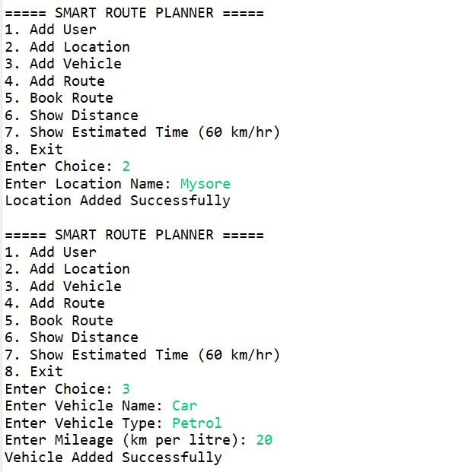
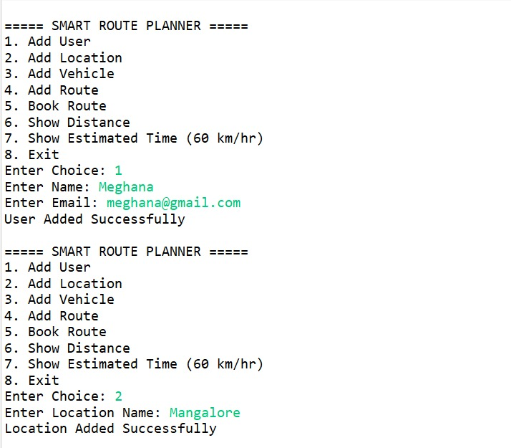

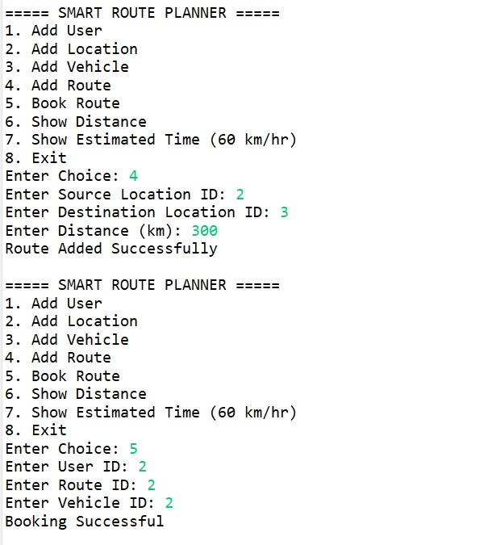

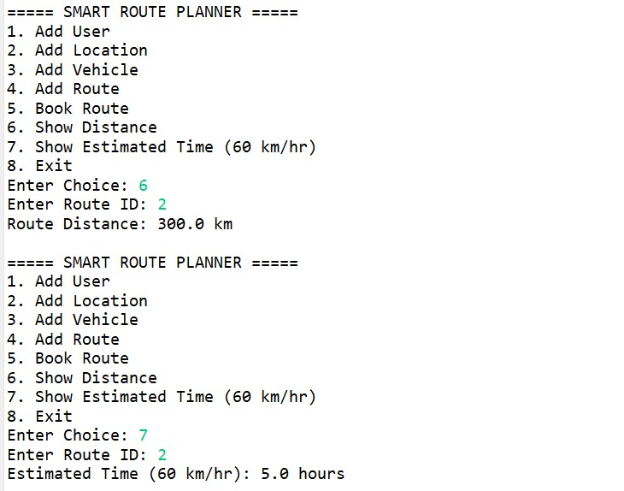
Conclusion:
The Smart Route Planning System project demonstrates how intelligent algorithms and real-time data integration can significantly improve navigation efficiency, reduce travel time, and optimize fuel consumption. By leveraging graph-based pathfinding algorithms such as Dijkstra’s Algorithm and A* Search, along with live traffic data and geolocation services, the system provides users with the most efficient and reliable routes.
The project highlights the importance of Geographic Information Systems (GIS), data structures, and optimization techniques in solving real-world transportation challenges. It also showcases how modern navigation platforms like Google Maps and Waze use intelligent routing and crowd-sourced traffic updates to enhance user experience.
Overall, the Smart Route Planning System contributes to smarter urban mobility, supports traffic management, and lays the foundation for future enhancements such as AI-based predictive traffic analysis, integration with IoT-enabled smart traffic systems, and eco-friendly route optimization. This project not only strengthens technical understanding of algorithms and system design but also demonstrates practical applications in transportation and smart city development.

References:
- Cormen, T. H., Leiserson, C. E., Rivest, R. L., & Stein, C. (2009). Introduction to Algorithms (3rd ed.). MIT Press.
- Dijkstra, E. W. (1959). “A Note on Two Problems in Connexion with Graphs.” Numerische Mathematik.
- Hart, P. E., Nilsson, N. J., & Raphael, B. (1968). “A Formal Basis for the Heuristic Determination of Minimum Cost Paths.” IEEE Transactions on Systems Science and Cybernetics.
- OpenStreetMap (2024). Open-source geographic data. Retrieved from https://www.openstreetmap.org
- Google Developers (2024). Google Maps Platform Documentation. Retrieved from https://developers.google.com/maps
- Russell, S., & Norvig, P. (2010). Artificial Intelligence: A Modern Approach (3rd ed.). Prentice Hall.
- IEEE Xplore Digital Library – Research papers on routing algorithms and intelligent transportation systems.

